

**CORPORATE WELLNESS - MENTAL HEALTH**

***OCTOBER 2018 NEWSLETTER***



# ISSUE FOCUS

Greetings,

We are excited to usher this new month together with you.

October 10th is World Mental Health day. We are on the frontline of championing for corporate wellness and mental health is a crucial part of this discussion.

We have encountered a lot of corporates who feel weighed down by the pressure of their jobs and the environment therein. In this issue, we tell you how to take care of your mental health.

-Public Image Team

## IMPORTANCE OF MENTAL HEALTH AWARENESS IN THE WORKPLACE

We all need to develop that safe space in our corporate environments where it’s okay to talk about mental health. This can be possible through counselling and employee assistance programs.

We all desire to have people really listen to what we are saying but we must give attention before expecting it. Leaders are



The corporate environment can be stressful and toxic. One out of three people has undergone mental

health problems at work. Employees are sometimes faced with extreme pressure to meet deadlines and targets which in turn causes them to develop mental health problems like stress, anxiety and depression.

We cannot separate mental wellness and organizational success. A stressed employee will produce less than average results which will affect overall organizational goals. These feelings directly affect job performance and productivity.

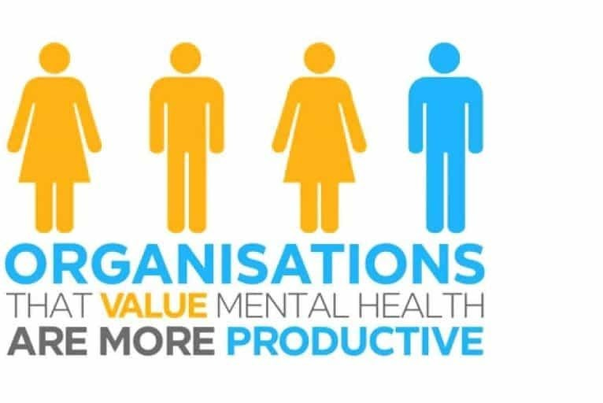

One of the greatest threats to mental

wholeness is the stigma associated with

known for listening and we are all leaders of our own lives. You are the CEO and

managing director of your life.

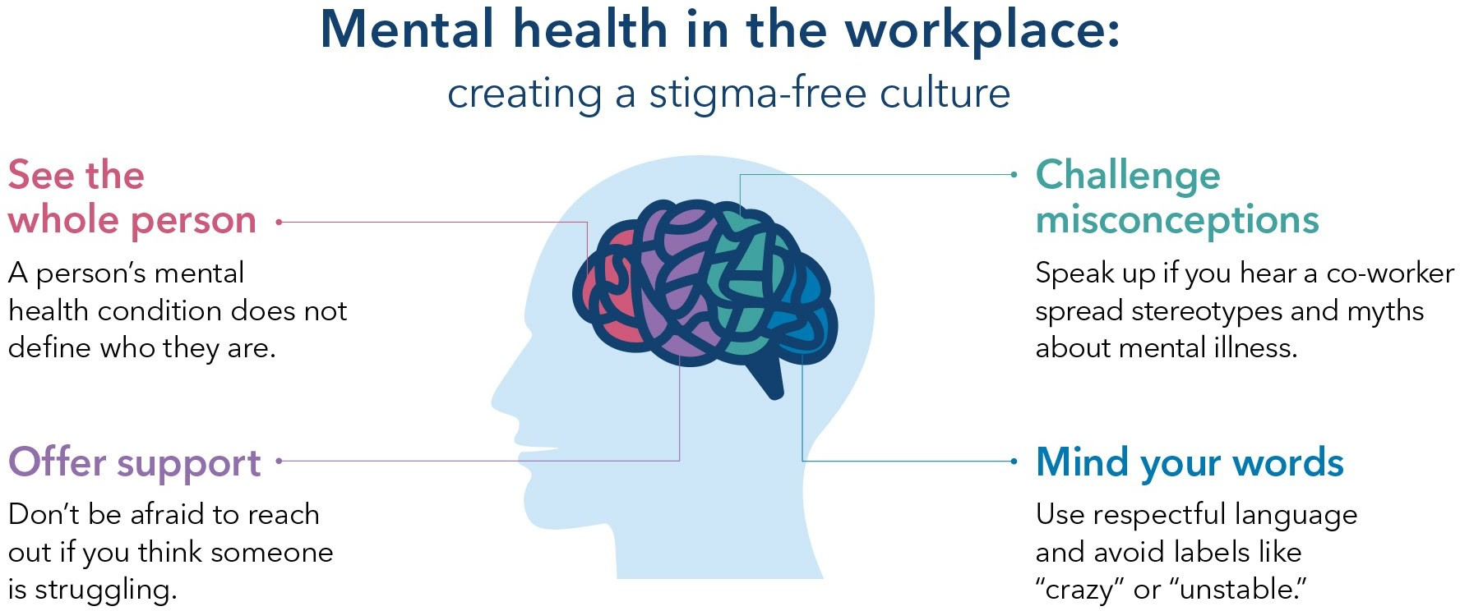

Conversely, employees with good mental health do well and they become invaluable to the company. Employees become 12% more productive when they are mentally healthy which begs the need to create a thriving environment to work in.

Everyone has a role to play in making the work place conducive. It is of vital

importance that positive mental health is encouraged.

Let us educate ourselves on mental health, lobby for awareness, foster acceptance and confront the false beliefs about mental health.

### Health is a state of body. Wellness is a state of being.

* *J. Stanford*

### Self-care is how you take your power back.

* *Ronny Simon*

disclosing the struggle with mental health which is why we are talking about it and encouraging conversations around it.

### You can’t pour from an empty cup. Take care of yourself ﬁrst.

* *Unknown*

## WAYS TO SUPPORT GOOD MENTAL HEALTH IN THE WORKPLACE

**Identify mental health problems**

One in four people are like to suffer from

mental health problems at one point in their lives. It is crucial to bring yourself up-to speed with what could potentially cause you years of pain and productivity. Employers should also equip themselves with this knowledge so that they can easily identify mental health problems. Early signs of

mental illness can be; Mood swings, nervousness, social withdraw, unproductivity, loss of initiative, bursts of anger, shifts in appetite or sleep, loss of memory and concentration and decline in personal care.

## Physical ﬁtness

Wellness is all-rounded. Exercising helps you build positive physical health experiences which generate positive emotions. There is a conﬁdence that comes with taking care of your physical health. You become more active in the

way you approach your work. Get enough sleep and maintain a healthy body as it

will contribute to a maintaining a healthy mind.

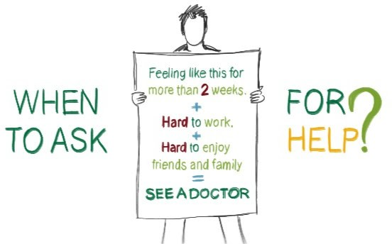

##### Create a healthy work environment

It is important, that you create a healthy work balance. De-clutter as often as you

can, organize your tasks and your hours in a way that doesn’t lead to burn out. Give

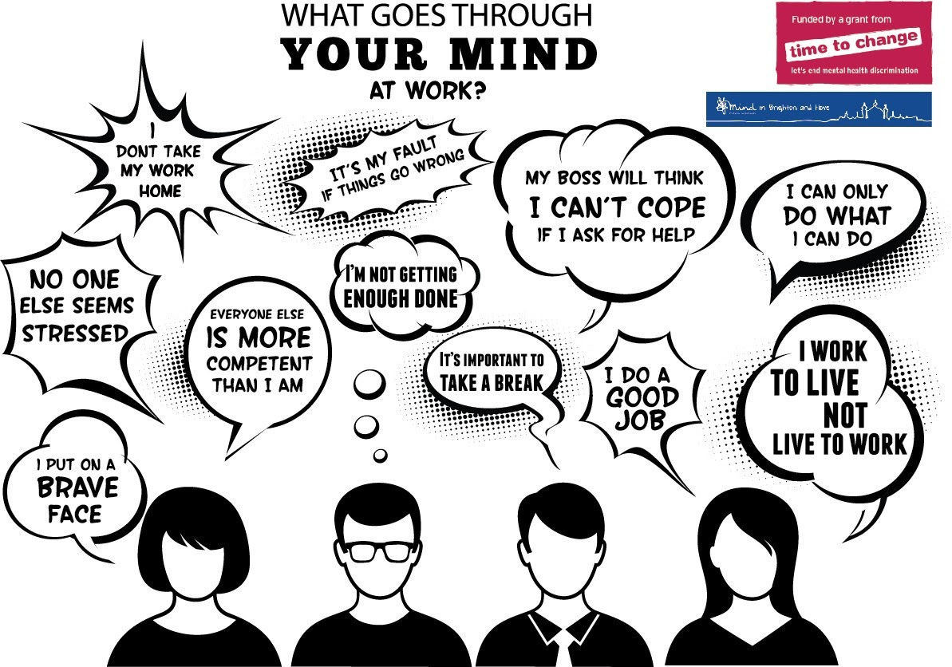

## Create positive connections

Your colleagues are as human as you are so make positive connections with them. There is a very thin line between professionalism and personal friendships but it shouldn’t keep you away from creating genuine connections. This way, it becomes easier for one to open up if they are struggling with

mental health. If people feel like you sincerely care about them, they can easily trust you. At the end of the day, human connections set the pace for every other thing.

yourself reasonable timelines to complete tasks so that you won’t ﬁnd yourself under pressure. Don’t overwork yourself and take the breaks given to you. Recharge

when you feel worn out. Avoid anything and anyone that weighs down your energy. Be mindful of others and create a thriving work environment for them too.

### The ability to be in the present is a major component of mental wellness.

– *Abraham Maslow*

### The mind and body are not separate. What affects one, affects the other.

* *Dr Joe*

### Be in love with your life. Every minute of it.

* *Jack Kerouac*

# Inspiration Corner

There was a popular speaker who hosted a seminar of 200 people. He held up 1,000ksh and asked, *‘Who would like this 1,000ksh?’* All 200 hands went up. He said, *‘I will certainly give this money to one of you but ﬁrst…’* He crumpled the 1,000ksh. *‘Who still wants it?’* He asked. All hands were raised. *‘What if I do this…?’* He dropped the note and stepped on it with his shoes. It was now dirty and crumpled. *‘Now, who still wants it?’* He asked. All 200 hundred hands went up. He went on to say, ‘We can all learn a lesson from this exercise. No matter what I did to the money, you still wanted it because it did not decrease in value. It’s still worth 1,000ksh. Life will crumple you and scrape you in the dirt. You will make poor decisions and deal with strained circumstances. Sometimes you will feel worthless but don’t ever forget

that you don’t decrease in value because of your circumstances. You are special. Hold yourself in high esteem.’

**Gallery Spot**

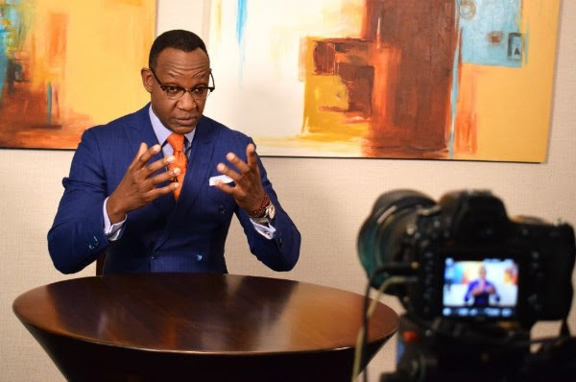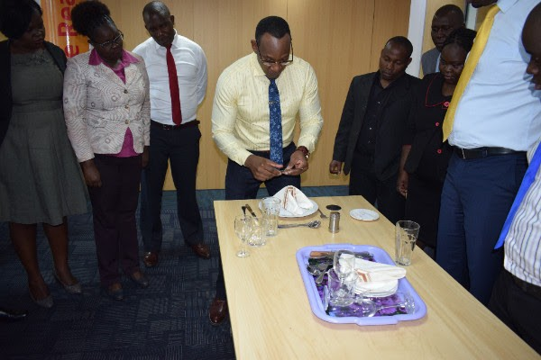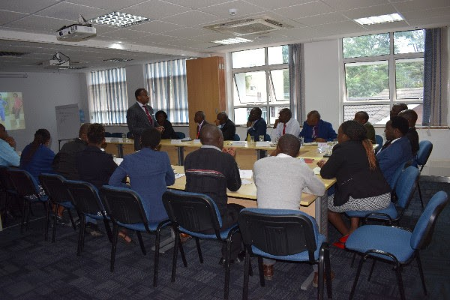

##### We would like to hear from you:

Public Image works with both individuals and companies. Our services include:

Mystery Shopping/ First Impressions audit Personal Branding, Image & Dress Professional Business and Social Etiquette Exceptional Customer Service

Emotional Intelligence and Assertiveness

Corporate Team Building Retreats Corporate Emceeing

Media Communication Skills

Find out how we can help by contacting any of the following:

*Joe:* [*joe.harvey@publicimageafrica.com*](mailto:joe.harvey@publicimageafrica.com)

*Shalom:* [*shalom.gichuki@publicimageafrica.com*](mailto:shalom.gichuki@publicimageafrica.com)

We have recently worked with:



[Facebook](https://archidatum.us7.list-manage.com/track/click?u=6be35792d22d0a8ae80d7f58b&id=60db0feb96&e=0c33a432d8) [Twitter](https://archidatum.us7.list-manage.com/track/click?u=6be35792d22d0a8ae80d7f58b&id=975af5ec51&e=0c33a432d8) [Website](https://archidatum.us7.list-manage.com/track/click?u=6be35792d22d0a8ae80d7f58b&id=b8c195ce3c&e=0c33a432d8) [Instagram](https://archidatum.us7.list-manage.com/track/click?u=6be35792d22d0a8ae80d7f58b&id=2580855c37&e=0c33a432d8)