

EMOTIONAL INTELLIGENCE

***FEBRUARY 2019 NEWSLETTER***

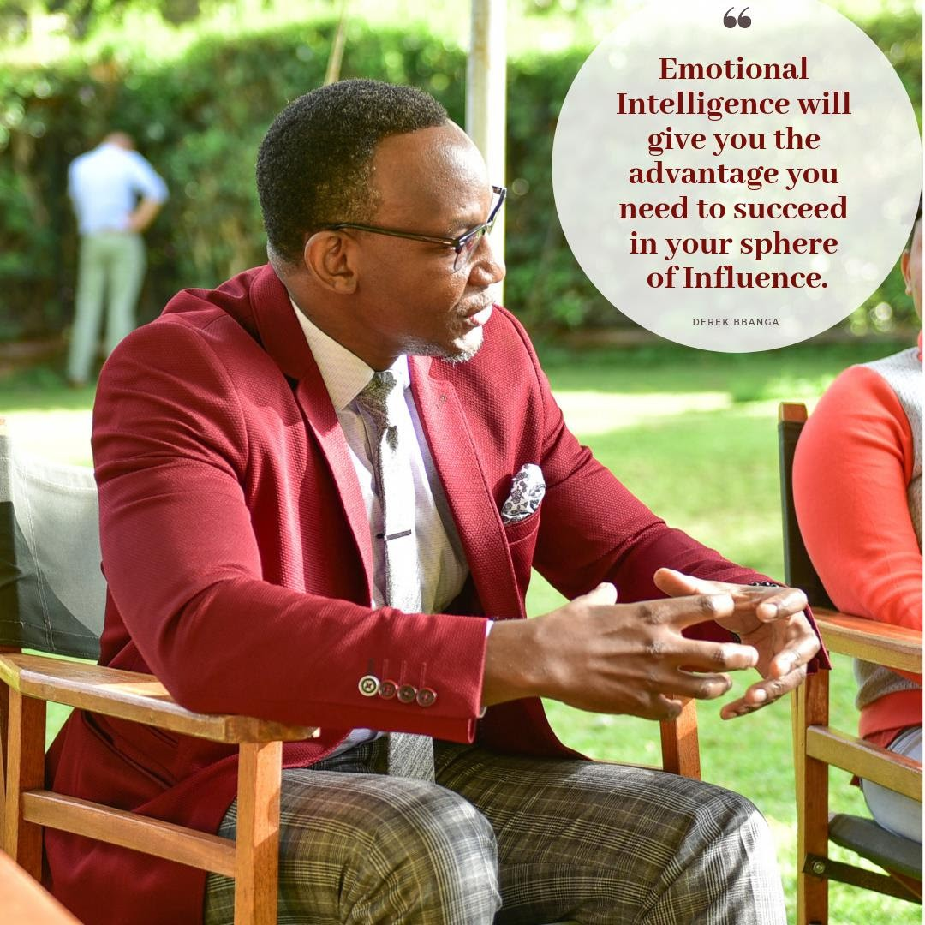

How well are you aware of your emotions? Do you recognize and empathize with other’s emotions? These and many other queries are why we are passionate on helping you elevate your Emotional Quotient.

Emotional Intelligence is the SI unit of great leaders and employees. This month’s newsletter explains the importance of EI to leaders. We welcome your team to

undertake our Emotional Intelligence program that will scale up your organizational success.

## With Our best Wishes, The Public Image Team.

**WHY THE BEST LEADERS DEVELOP MINDFULNESS & EMOTIONAL INTELLIGENCE**



What have Google, Samsung, Aetna, SAP, and P&G all got in common? All of these world-class organisations recognise that one of the fastest growing segments of our working population is burned out

leaders. They all responded to this by implementing mindfulness leadership programs to help their leaders not only

excel in work, but in their personal lives as well.

Decades of solid research show a direct connection between mindfulness and

emotional intelligence in leaders and the bottom-line results they achieve. Being good at ‘what you do’ is no longer enough…you must also be resilient enough to effectively manage your emotions, reactions and decisions in challenging business situations – and to help the people you manage, or work with, to do the same.

Great leaders are always searching for ways to take their leadership practices to the next level. Mindfulness has been the source of much focus over the last number of years and organisations

worldwide are now realising that sometimes there is more to a successful leader than meets the eye.

Developing emotional intelligence and

mindfulness can truly transform the impact and ability of a leader. Following this Leadership Model:

1. When you develop self-awareness, you become an Aware Leader. Aware leaders understand the impact their behaviours have on others. They are consistent in what they say and do, and they demonstrate awareness of their mood and emotions.
2. Developing awareness of others allows you to become a more Empathetic Leader. Empathetic leaders make others feel appreciated and adjust their style so that it ﬁts well with others. They acknowledge the

views of others and balance achieving results with others’ needs.

1. 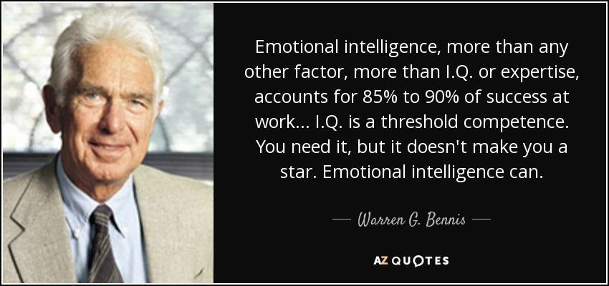Working on authenticity creates more Genuine Leaders. Genuine leaders honour commitments and promises, they are open and honest about mistakes, and they facilitate robust and open debate.
2. Leaders high in emotional reasoning make Expansive decisions as leaders. Expansive leaders consult others in decision making, they make ethical decisions taking the bigger picture into account.
3. Leaders that work to develop self- management are Resilient Leaders.

Resilient Leaders manage their emotions well in difﬁcult situations. They strive to

improve their own performance, and they learn from their mistakes.

1. Effective leaders that inspire performance become Empowering Leaders. Empowering leaders provide constructive feedback,

maintain a positive work environment and facilitate the team member development and career advancement.

# PUBLIC IMAGE NEWS: GENOS CERTIFICATION

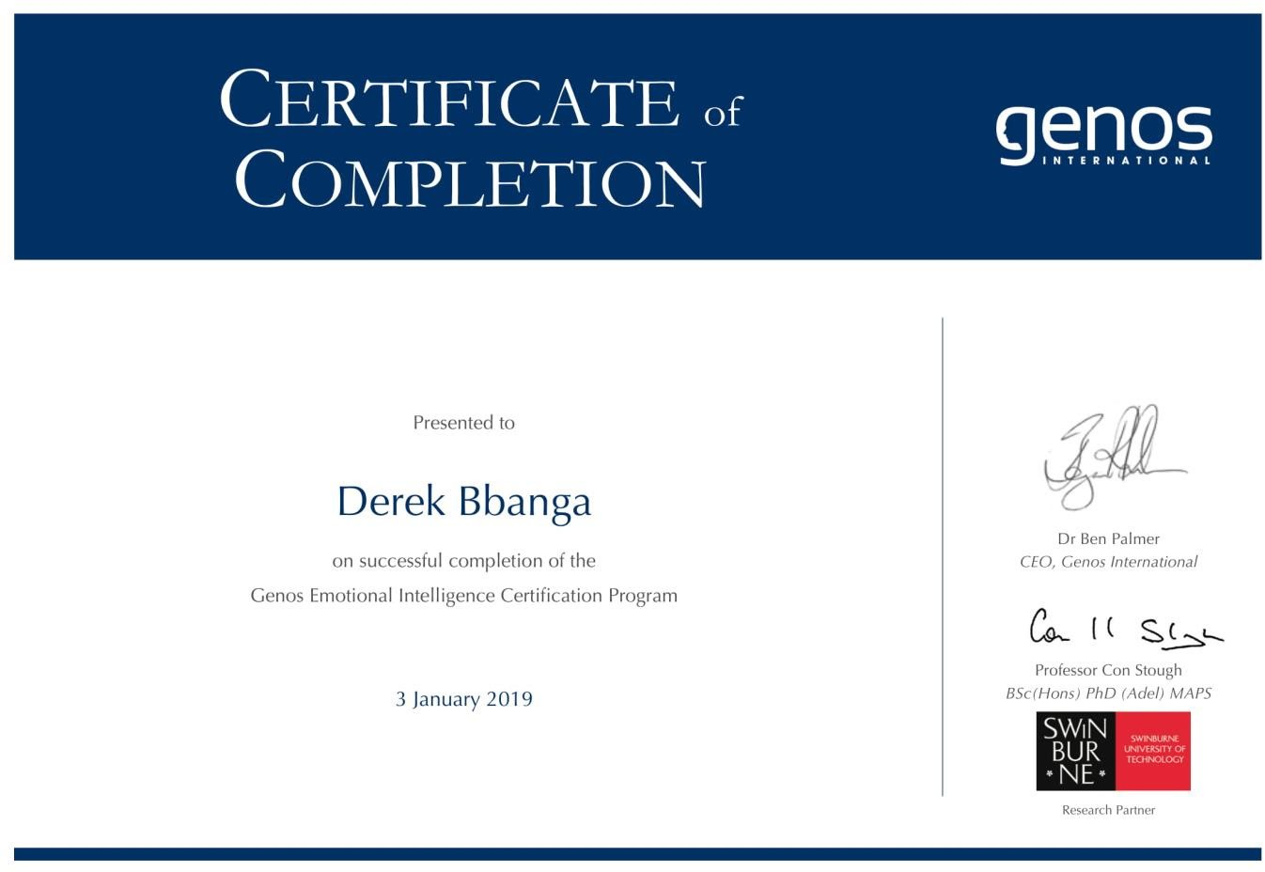



*Derek Bbanga discussing Emotional Intelligence on the TV Program ‘Living With Ess’*

We recently had an insightful session with young leaders from all over Africa under YALI Organization. The conversation revolved around Leadership and soft skills particularly Emotional Intelligence. Here is some of their feedback from twitter;

Soft skills are not a good to have, they are a MUST have skills for a leader!

[@derekbbanga](https://publicimageafrica.us7.list-manage.com/track/click?u=5f227ce6f4d1d6e428e1f1079&id=cd17e4fcd3&e=14cd4422d1)

[#YALITransformation](https://publicimageafrica.us7.list-manage.com/track/click?u=5f227ce6f4d1d6e428e1f1079&id=de4ca004db&e=14cd4422d1)

[#MyDayinYALIRLCEA](https://publicimageafrica.us7.list-manage.com/track/click?u=5f227ce6f4d1d6e428e1f1079&id=30f6a134b4&e=14cd4422d1)

"People forget what you said, will forget what you did. But

people will never forget how you made them feel." Maya Angelo.

[@USAID](https://publicimageafrica.us7.list-manage.com/track/click?u=5f227ce6f4d1d6e428e1f1079&id=d57cf4a10d&e=14cd4422d1)

[@DHWYTanzania](https://publicimageafrica.us7.list-manage.com/track/click?u=5f227ce6f4d1d6e428e1f1079&id=b1eafb3f1f&e=14cd4422d1) [@YALIRLCEA](https://publicimageafrica.us7.list-manage.com/track/click?u=5f227ce6f4d1d6e428e1f1079&id=aaa469c077&e=14cd4422d1)

[@USEmbassyKenya](https://publicimageafrica.us7.list-manage.com/track/click?u=5f227ce6f4d1d6e428e1f1079&id=aa04efe9d5&e=14cd4422d1) [@USAID](https://publicimageafrica.us7.list-manage.com/track/click?u=5f227ce6f4d1d6e428e1f1079&id=19e66fd618&e=14cd4422d1)

[@suleykuchengo](https://publicimageafrica.us7.list-manage.com/track/click?u=5f227ce6f4d1d6e428e1f1079&id=1f0fbe4633&e=14cd4422d1) [pic.twitter.com/CeAnM2](https://publicimageafrica.us7.list-manage.com/track/click?u=5f227ce6f4d1d6e428e1f1079&id=f40f84dc8c&e=14cd4422d1)

[StKf](https://publicimageafrica.us7.list-manage.com/track/click?u=5f227ce6f4d1d6e428e1f1079&id=f40f84dc8c&e=14cd4422d1)

— Kalvince

(@KalvinceOfﬁcia)

[January 30, 2019](https://publicimageafrica.us7.list-manage.com/track/click?u=5f227ce6f4d1d6e428e1f1079&id=fd92de3d38&e=14cd4422d1)

At time we need to make best decisions &

not hurt peoples feelings & that's best attained with high emotional

intelligence.[@YALIRLC](https://publicimageafrica.us7.list-manage.com/track/click?u=5f227ce6f4d1d6e428e1f1079&id=63f070df4b&e=14cd4422d1)

[EA#](https://publicimageafrica.us7.list-manage.com/track/click?u=5f227ce6f4d1d6e428e1f1079&id=5637901e99&e=14cd4422d1)

[MyDayinYALIRLCEA](https://publicimageafrica.us7.list-manage.com/track/click?u=5f227ce6f4d1d6e428e1f1079&id=5637901e99&e=14cd4422d1)

— marion mutuku (@mutukumarion)

[January 30, 2019](https://publicimageafrica.us7.list-manage.com/track/click?u=5f227ce6f4d1d6e428e1f1079&id=386071c7ba&e=14cd4422d1)

Just saying thank you is an understatement!

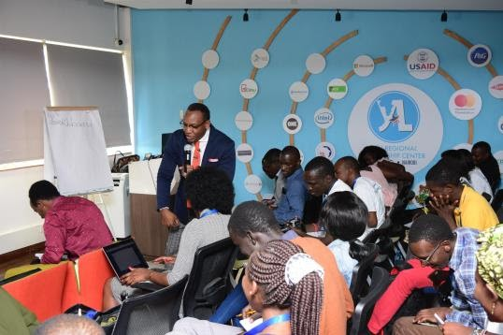[@derekbbanga](https://publicimageafrica.us7.list-manage.com/track/click?u=5f227ce6f4d1d6e428e1f1079&id=db3601332e&e=14cd4422d1) The way you show up

affects the way people feel and the way they feel affects how they engage with you

[#inspirationalTalk#](https://publicimageafrica.us7.list-manage.com/track/click?u=5f227ce6f4d1d6e428e1f1079&id=921626c75f&e=14cd4422d1)

[M](https://publicimageafrica.us7.list-manage.com/track/click?u=5f227ce6f4d1d6e428e1f1079&id=921626c75f&e=14cd4422d1)[yDayinYALIRLCEA#](https://publicimageafrica.us7.list-manage.com/track/click?u=5f227ce6f4d1d6e428e1f1079&id=5f7fdeb928&e=14cd4422d1)

[YALITransformation](https://publicimageafrica.us7.list-manage.com/track/click?u=5f227ce6f4d1d6e428e1f1079&id=5f7fdeb928&e=14cd4422d1)

[#MyleadershipJourney](https://publicimageafrica.us7.list-manage.com/track/click?u=5f227ce6f4d1d6e428e1f1079&id=f80639e28d&e=14cd4422d1) [@USAID](https://publicimageafrica.us7.list-manage.com/track/click?u=5f227ce6f4d1d6e428e1f1079&id=0748d67f8f&e=14cd4422d1)[@YALIRLCEA](https://publicimageafrica.us7.list-manage.com/track/click?u=5f227ce6f4d1d6e428e1f1079&id=e366ca01b7&e=14cd4422d1)

[@BanviYann](https://publicimageafrica.us7.list-manage.com/track/click?u=5f227ce6f4d1d6e428e1f1079&id=d222b20037&e=14cd4422d1)

[@mahamudfara](https://publicimageafrica.us7.list-manage.com/track/click?u=5f227ce6f4d1d6e428e1f1079&id=9aeb7d093b&e=14cd4422d1)[h@Est](https://publicimageafrica.us7.list-manage.com/track/click?u=5f227ce6f4d1d6e428e1f1079&id=6ba6d7d220&e=14cd4422d1)

[herkiarie@](https://publicimageafrica.us7.list-manage.com/track/click?u=5f227ce6f4d1d6e428e1f1079&id=0e456013f0&e=14cd4422d1)

[BBwibo](https://publicimageafrica.us7.list-manage.com/track/click?u=5f227ce6f4d1d6e428e1f1079&id=0e456013f0&e=14cd4422d1)[@nurkeycade](https://publicimageafrica.us7.list-manage.com/track/click?u=5f227ce6f4d1d6e428e1f1079&id=9389e7c0ae&e=14cd4422d1) [pic.twitter.com/YPhPvo](https://publicimageafrica.us7.list-manage.com/track/click?u=5f227ce6f4d1d6e428e1f1079&id=f474e342c4&e=14cd4422d1)

[DSwv](https://publicimageafrica.us7.list-manage.com/track/click?u=5f227ce6f4d1d6e428e1f1079&id=f474e342c4&e=14cd4422d1)

— Judith Mong'eri (@judithmongeri)

[January 30, 2019](https://publicimageafrica.us7.list-manage.com/track/click?u=5f227ce6f4d1d6e428e1f1079&id=847dfee133&e=14cd4422d1)

**GALLERY**



[Emotional Intelligence in the workplace](https://publicimageafrica.us7.list-manage.com/track/click?u=5f227ce6f4d1d6e428e1f1079&id=23858233fd&e=14cd4422d1) with Derek and Sharon Mundia.

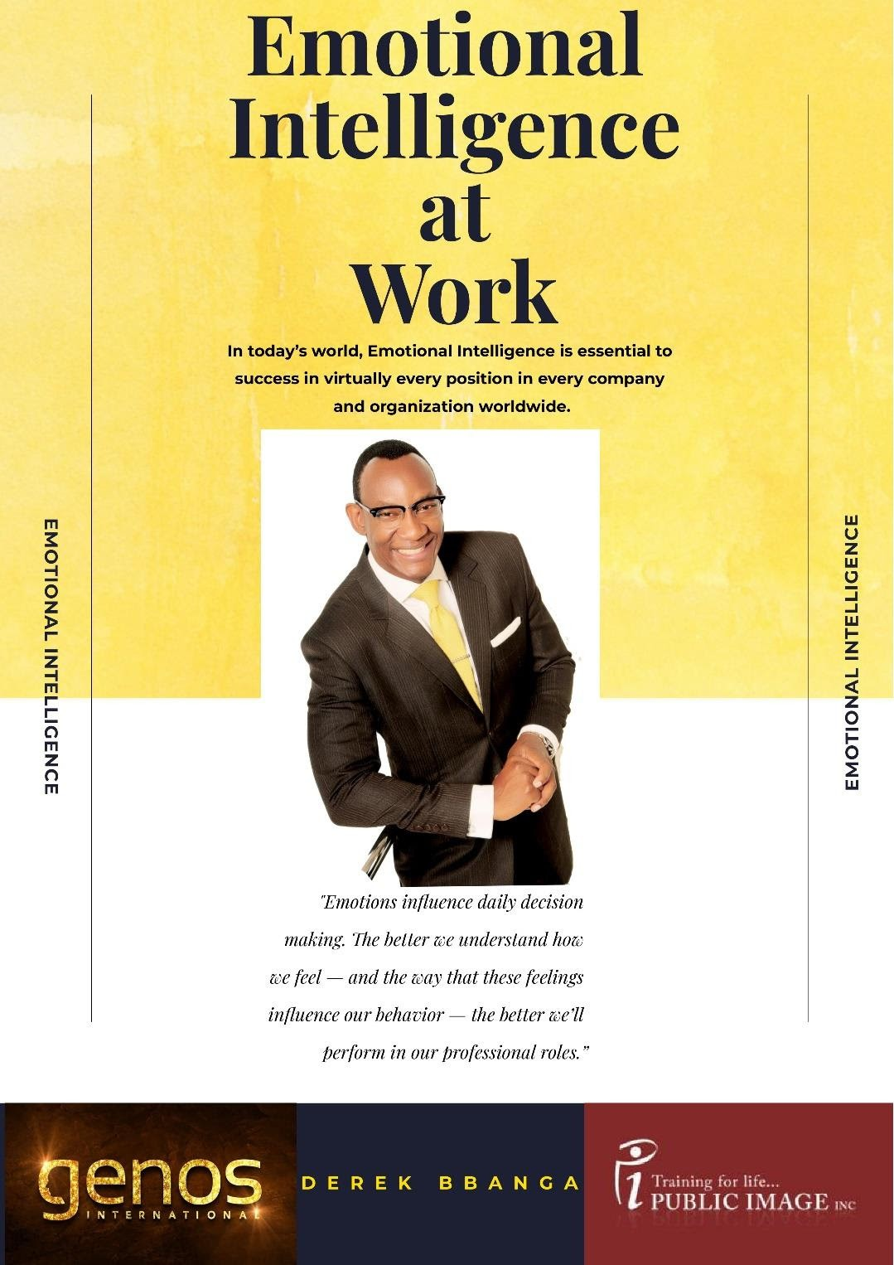**QUOTES OF THE MONTH**

It always seems impossible until it’s done.

***- Nelson Mandela***

You don’t get to the top by doing what everyone else is doing.

***-Mark Twain***

Dreams and Dedication are a powerful combination.

***-William Long-good***

Whether you think you can or you can’t, you’re right.

***–Henry Ford***

Action is the foundation key to all success.

***-Pablo Picasso***

## We would like to hear from you:

Public Image works with both individuals and companies. Our services include:

Mystery Shopping/ First Impressions audit Personal Branding, Image & Dress Professional Business and Social Etiquette Exceptional Customer Service

Emotional Intelligence and Assertiveness Corporate Team Building Retreats

Corporate Emceeing

Media Communication Skills

Find out how we can help by contacting any of the following:

*Shalom:* [*shalom.gichuki@publicimageafrica.com*](mailto:shalom.gichuki@publicimageafrica.com)

We have recently worked with:



[Facebook](https://publicimageafrica.us7.list-manage.com/track/click?u=5f227ce6f4d1d6e428e1f1079&id=beff29abe3&e=14cd4422d1) [Twitter](https://publicimageafrica.us7.list-manage.com/track/click?u=5f227ce6f4d1d6e428e1f1079&id=36ed69d01f&e=14cd4422d1) [Website](https://publicimageafrica.us7.list-manage.com/track/click?u=5f227ce6f4d1d6e428e1f1079&id=8414242b4c&e=14cd4422d1) [Instagram](https://publicimageafrica.us7.list-manage.com/track/click?u=5f227ce6f4d1d6e428e1f1079&id=459901afb3&e=14cd4422d1)

Personal Training · Wilson Business Park, 2nd Floor, Block Bravo, Langata Road · P.O. Box 856 · Nairobi 00606 · Kenya

