[](https://publicimageafrica.us7.list-manage.com/track/click?u=5f227ce6f4d1d6e428e1f1079&id=e7e46ad25e&e=14cd4422d1)

***MARCH 2019 NEWSLETTER***

FROM DAB TO FAB!

WOMEN’S ISSUE

[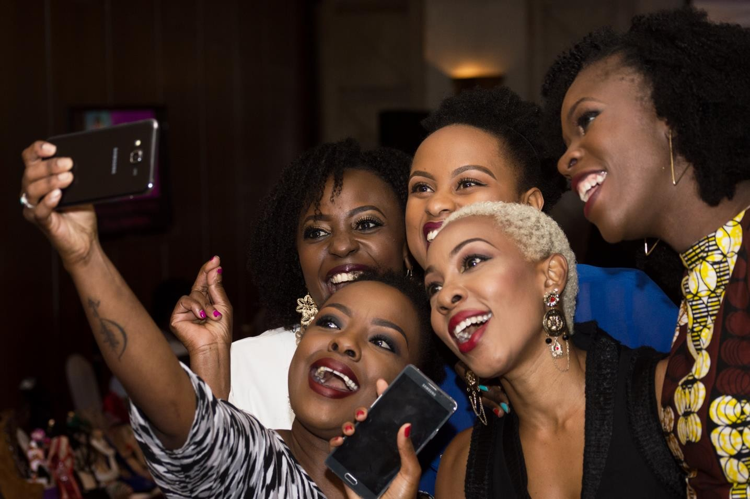](https://publicimageafrica.us7.list-manage.com/track/click?u=5f227ce6f4d1d6e428e1f1079&id=1cb3c57c4b&e=14cd4422d1)

## Issue Focus:

Greetings,

Happy New Month!

8th of March is International Women’s day and we would like to celebrate all the amazing women we work with by dedicating this month’s newsletter to them.

From Dab to Fab issue highlights Career mistakes women should avoid when trying to climb the corporate ladder and tips on

dressing. We appreciate you and we want to see you rise to the top and rule the world like the boss ladies you are!

# Common Career mistakes women should avoid

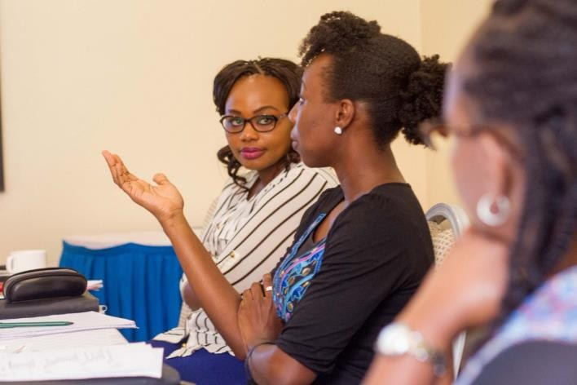

Hillary Clinton is quoted saying, ‘When more women enter the workforce it spurs innovation, increases productivity and grows economies.’ Companies want to know how to ﬁnd and keep high value women but it is no myth that most women ﬁnd themselves stuck in positions they’ve held for years. Wondering how to step it up to the next level? Let’s see if you’re making any of these career mistakes that most women make!

### Downplaying your Emotional Intelligence

Women surpass men on four of ﬁve

### Acting like a man

You don’t need to act like a man for you to succeed. Leverage the power of your femininity and uniqueness instead of adapting fake machismo. Be yourself, bring value to the table, treat people with professionalism and work the room with grace and class. Remember, people don’t like a dealing with a damsel in distress wannabe but a woman who takes her rightful place and gets the work done.

### Neglecting your personal brand

Deﬁne and reﬁne the story you want people to have about you. What are you best known for? What communicates your values, personality and your ability?

Control the narrative by being really good at what you do. Clearly communicate what sets you apart from every other person who deserves that job/promotion/assignment.

measure of Emotional Intelligence namely self-awareness, self-regulation, empathy and social skills. Despite this fact, women still assume that the more they work hard, the easier they’ll be recognized. EI will do for you what your intelligence and sheer hard work cannot. It is the advantage you have naturally to succeed in your sphere of inﬂuence so look for ways to grow it and make it work for you.

### Disregarding the signiﬁcance of networking

Relationships are important when you’re trying to scale up. You can always use them to your advantage and your success. Build networks with co-workers, clients, suppliers and people in your professional ﬁeld and even in other ﬁelds. People buy from people they like so create the effort to have links that you can rely on.



### Waiting to be noticed

Verbally express what you want; a salary increment, promotion, transfer, assignment. The men do it, why not women? This has nothing to do with humility but everything to do with accomplishing your goals and getting ahead. Showcase your achievements, express your interests and form solid relationships with seniors in your organization who will advocate for you if there arises a position you’re interested in.

# The Career Woman’s guide to Appropriate but Fab Dressing

**Pants and suits:** Pants are ﬁne, but stick to tailored pants with a crease. Khaki, twill, and corduroy are good fabric choices for business casual but stay away from denim. Pants and suits made from wool, and wool blends are good standard

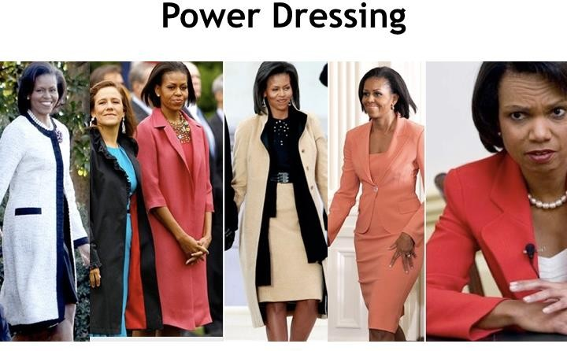

**Wear tailored clothing:** Tailored clothing always looks better. It pays to invest in several high quality outﬁts that are interchangeable than in multiple poor quality outﬁts.

**Creativity:** Remain stylish and creative in your dressing. We advise that you always use your best judgement, it is important to note that the beauty industry is not too formal but neither should it be casual. To ensure professionalism be modest and decent in the way you dress.

**Colour and patterns:** Conservative colours and fabrics remain a standard in business attire for men and women. Wear dark grey or navy pants and suits. Women can also wear black if the clothing itself is professional.

**Avoid pattern extremes.** You want to make a statement about your business not a personal statement expressing your passion for purple polka dots.

business attire and work for all seasons. Try to avoid synthetic fabrics like rayon and polyester blends.

**Skirts and dresses:** The right colour and material are important but the right length is critical – on or slightly above or below the knee is acceptable. If you sit in a chair and can see too much thigh with legs crossed or uncrossed the outﬁt is too short.

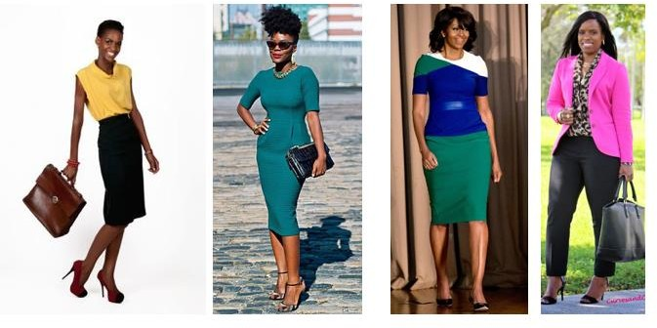

**Shoes:** Closed-toed shoes in a colour that compliments your outﬁt are best. Black, brown and navy blue are acceptable. Do not wear chunky heels, ﬂat soled-shoes, stilettos, or shoes with too much height – keep to a three inch maximum. It is important to wear shoes that ﬁt well so you can walk comfortably.

**Shoes should be polished and clean and made of leather:** Sandals are never appropriate for business attire but open toed shoes may be ﬁne for business casual.

**Make sure pants are pressed and as wrinkle free as possible.** The hem should cover the ankle but not drape to the ﬂoor. Even if you have a lovely ﬁgure stay away from pants that are too tight.

*Derek Bbanga discussing Emotional Intelligence on the TV Program ‘Living With Ess’*

**SPOTLIGHT**

[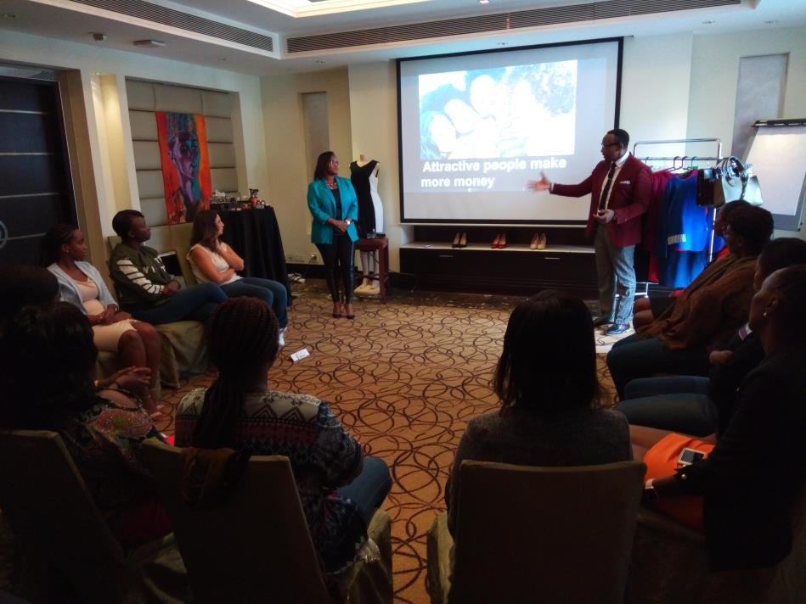](https://publicimageafrica.us7.list-manage.com/track/click?u=5f227ce6f4d1d6e428e1f1079&id=988dd55a13&e=14cd4422d1)

A recent ‘From Dad to Fab’ training of women managers at Sankara

## QUOTES OF THE MONTH

A strong woman looks at a challenge in the eye and gives it a wink.

**– Gina Carey**

Women are the architects of society.

**–Cher**

There’s no force more powerful than a woman determined to rise.

* **Unknown**

A lady should be two things. Classy and Fabulous.

* **Coco Chanel**

‘Cause I’m a woman. Phenomenally. Phenomenal woman, that’s me.

* **Maya Angelou**

She believed she could, so she did.

* **Gasheri**

Character. Intelligence. Strength. Style. That makes beauty.

* **Diane Von Fustenberg**

Empowered women empower women.

**- Michelle Obama**

Girls should never be afraid to be smart.

* **Emma Watson**

You are enough!

* **Public Image Team**

### We would like to hear from you:

Public Image works with both individuals and companies. Our services include:

Mystery Shopping/ First Impressions audit Personal Branding, Image & Dress Professional Business and Social Etiquette Exceptional Customer Service

Emotional Intelligence and Assertiveness Corporate Team Building Retreats Corporate Emceeing

Media Communication Skills

Find out how we can help by contacting any of the following:

*Shalom:* [*shalom.gichuki@publicimageafrica.com*](mailto:shalom.gichuki@publicimageafrica.com)

We have recently worked with:



[](https://publicimageafrica.us7.list-manage.com/track/click?u=5f227ce6f4d1d6e428e1f1079&id=76bb9610be&e=14cd4422d1)[](https://publicimageafrica.us7.list-manage.com/track/click?u=5f227ce6f4d1d6e428e1f1079&id=6a75a041de&e=14cd4422d1)[](https://publicimageafrica.us7.list-manage.com/track/click?u=5f227ce6f4d1d6e428e1f1079&id=c770914619&e=14cd4422d1)[](https://publicimageafrica.us7.list-manage.com/track/click?u=5f227ce6f4d1d6e428e1f1079&id=3c26990eea&e=14cd4422d1)[Facebook](https://publicimageafrica.us7.list-manage.com/track/click?u=5f227ce6f4d1d6e428e1f1079&id=23c89bb213&e=14cd4422d1) [Twitter](https://publicimageafrica.us7.list-manage.com/track/click?u=5f227ce6f4d1d6e428e1f1079&id=d647d23fc0&e=14cd4422d1) [Website](https://publicimageafrica.us7.list-manage.com/track/click?u=5f227ce6f4d1d6e428e1f1079&id=56e0734140&e=14cd4422d1) [Instagram](https://publicimageafrica.us7.list-manage.com/track/click?u=5f227ce6f4d1d6e428e1f1079&id=8ac0a6d3f6&e=14cd4422d1)

[](http://www.mailchimp.com/email-referral/?utm_source=freemium_newsletter&utm_medium=email&utm_campaign=referral_marketing&aid=5f227ce6f4d1d6e428e1f1079&afl=1)